**ODE:**

import java.util.Scanner;

public class Practical_3_5 {

    public static *void* main(String *args*[]) {

        Scanner sc = new Scanner(System.in);

*int* l, b;

        System.out.println("Enter The Length of Rectangle: ");

        l = sc.nextInt();

        System.out.println("Enter The Breadth of Rectangle: ");

        b = sc.nextInt();

        area object = new area(l, b);

        System.out.println("\nArea of rectangle is: " + object.returnarea());

        System.out.println("\n20DCE019-Yatharth Chauhan");

    }

}

class area {

*int* length, breadth;

    area(*int* *l*, *int* *b*) {

        length = *l*;

        breadth = *b*;

    }

    public *int* returnarea() {

        return length * breadth;

    }

}

**OUTPUT:**

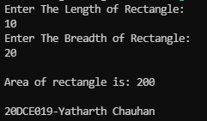

**CONCLUSION:** In this program we used parameters in the function and we passed the values from one class to another, did some operations and then we returned its value to previous class.